**A PROJECT REPORT**



**DEPARTMENT OF COMPUTER SCIENCE AND APPLICATIONS**



**PANJAB UNIVERSITY, CHANDIGARH**

**FOR THE PARTIAL FULFILLMENT FOR QUALIFYING BCA**

**DEGREE**

**SUBMITTED TO: SUBMITTEDBY:**

**Ms. MONICA**  **ABHAY SINGH (4217/16)**

**ABHISHEK BHATIA(4287/16)**

**Acknowledgement**

A formal statement of acknowledgement is hardly sufficient to express our gratitude towards the personalities who have helped us to undertake and carry out this project. We hereby convey our thankfulness and obligation to all those who are providing us valuable help, support and guidance to carry on this project. We take this opportunity to express our deepest gratitude to those who have generously helped us in providing the valuable knowledge and expertise during our Project.

We are thankful to Ms. Monica (Lecturer) of Department Of IT, PGGC-11 Chandigarh, for her thorough guidance right from day 1st till the end of the Project and giving us the required guidance and removing any difficulties faced by us during the project.

We would like to thank each and every person who has contributed in any of the ways in my training. We thank the almighty god for blessing us with new challenges in life and giving us enough strength to meet those challenges. We owe everything to our parents who worked very hard to provide us everything in life.

Finally we are indebted to our friends who showed tolerance and maturity when we were preoccupied with composition of the project cannot be expressed in words.

**Post Graduate Government College, Sector 11**

**Panjab University**, **Chandigarh**

**CERTIFICATE**

**TO WHOM SO EVER IT MAY CONCERN**

**This is to certify that ABHAY SINGH(4217/16) and ABHISHEK BHATIA (4287/16)** pursuing **Bachelor of Computer Applications**, at Post Graduate Government College, Sector 11, Chandigarh, undertook a project entitled ”**Android** **Webview browser” ,** the project is a bonafide work carried out by themunder our supervision. This work has not been submitted earlier, either in part or in full, to any other university or institute for the award of degree.

**Ms. Monica**

**(Project Guide)**

**PGGC, Sector-11, Chandigarh**

**TABLE OF CONTENTS**

|  |  |  |
| --- | --- | --- |
| **Sr.no** | **Title** | **Page no.** |
| **I** | **Introduction**  Project Introduction  About Organization (i.e. about college and department) | 1-2 |
| **II** | Data Flow Diagram (DFDs)  Minimum Hardware and Software Specifications | 3-6 |
| **III** | **System Design**  Snapshots | 7-9 |
| **IV** | **Source Code** | 10-20 |
| **V** | **Conclusions**  Limitations  Future scope of the project  Bibliography | 21 |

Teacher’s sign- ______________

**INTRODUCTION**



**App Icon**

**Application Name:** LiteWeb

Lite Web is an android app made with the help of android studio using webview class and java programming. WebView is a view that display web pages inside your application. You can also specify HTML string and can show it inside your application using WebView. WebView makes turns your application to a web application.

In order to add WebView to your application, you have to add <WebView> element to your xml layout file. Its syntax is as follows −

<WebView xmlns:android="http://schemas.android.com/apk/res/android"

android:id="@+id/webview"

android:layout_width="fill_parent"

android:layout_height="fill_parent"

/>

In order to use it, you have to get a reference of this view in Java file. To get a reference, create an object of the class WebView. Its syntax is −WebView browser = (WebView) findViewById(R.id.webview);In order to load a web url into the WebView, you need to call a method loadUrl(String url) of

the WebView class, specifying the required url. Its syntax is: browser.loadUrl("http://www.google.com");

**ABOUT ORGANISATION**

**PGGC11**

Post Graduate Government College, Sector 11, Chandigarh is as old and as young as the City Beautiful. Its growth and expansion have kept pace with the growth and expansion of the city. The college was envisaged as a leading institution having its own distinct impress on the educational and cultural map of the ‘City Beautiful’. A prestigious temple of learning, (just in the footsteps of famous Govt. College, Lahore), that could grow into an epicenter of intellectual and aesthetic activities in the region.

Being the first college in the city, it has proved itself eminently worthy of its role as a torch-bearer in the whole gamut of broad-based instruction. The college aims at providing congenial atmosphere and constructive channels to its young scholars for the fullest development of their multi-dimensional personalities. It has always been our earnest Endeavour to direct the collective efforts towards the inculcation of intellectual brilliance, moral uprightness, and ethical awareness, so as to shape young boys and girls into responsive and responsible members of society. ‘Higher and Still higher’ is the motto of the college.

**IT DEPARTMENT**

The Department is headed by  as far as Department is concerned, academic standards and placements are the two key parameters. Our academic standards have been achieved by the intellectual property of our faculty. The faculty strives to foster and encourage a teaching methodology that is both practical and theoretical in approach. This orientation has led to successful training and placements.

The reason students select Information Technology is not only because of the physical infrastructure, which is all there; but because of the soft factors. Soft factors like our approach to academics, our intellectual property, training and placement. The quality of academic instructions, conduct guidelines and college activities are designed to produce competent and successful engineers. In the Department the focus is on preparing professional engineers. As they say an engineer is for today, while a professional engineer is forever.

**DATA FLOW DIAGRAM**

**Data Flow Diagrams show the flow of data from external entities into the system, and from one process to another within the system. There are four symbols for drawing a DFD:**

**1. Rectangles representing external entities, which are sources or destinations of Data.**

**2. Ellipses representing processes, which take data as input, validate and process it and output it.**

**3. Arrows representing the data flows, which can either, be electronic data or physical items.**

**4. Open-ended rectangles or a Disk symbol representing data stores.**

**The Context Level DFD provides a conceptual view of the process and its surrounding input, output and data stores. The Detailed DFD provides a more detailed and comprehensive view of the interaction among the sub-processes within the system.**

**Level 0 (Conceptual DFD)**

Highest abstraction level DFD is known as Level 0 DFD, which depicts the entire information system as one diagram concealing all the underlying details. Level 0 DFDs are also known as context level DFDs.

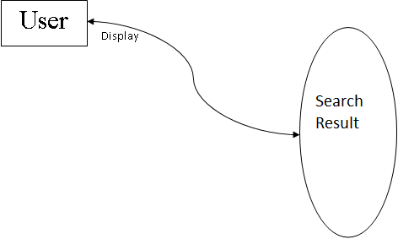

**Level 1(Detailed)** - The Level 0 DFD is broken down into more specific, Level 1 DFD. Level 1 DFD depicts basic modules in the system and flow of data among various modules. Level 1 DFD also mentions basic processes and sources of information.

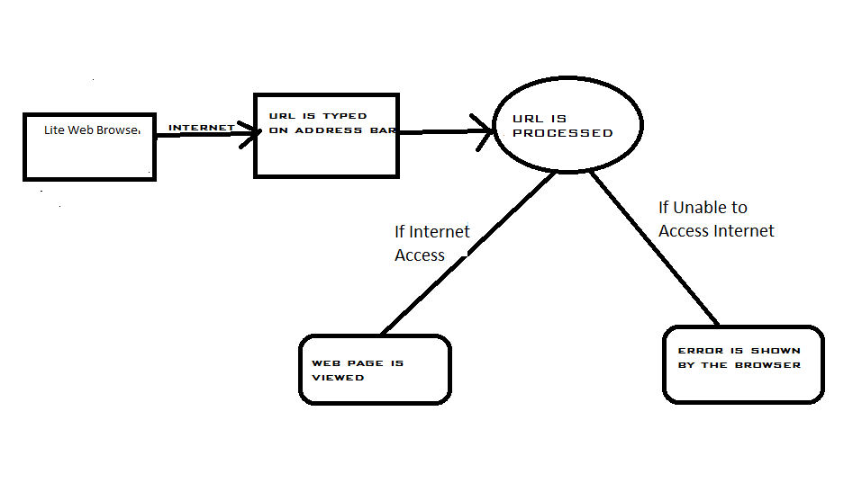

**DFD LEVEL 1**

**MINIMUM HARDWARE AND SOFTWARE SPECIFICATIONS**

**SOFTWARE REQUIREMENTS**

ANDROID 4.0 and above

**HARDWARE REQUIREMENTS**

**Processor**

* Dual Core Processor

**RAM**

* + 512 MB and above

**Hard Disk**

* Minimum 5 MB free internal storage space

**OS Requirements:**

Android v4.0 and above.

**SYSTEM DESIGN**

Design is the most important part of the development phase for any product or system because design is the place where quality is fostered. Design is the only thing, which accurately translates a user requirement in to a finished software product or system. The design step produces a data design, an architectural design, and Interface Design and a Procedural Design. System specialist often refers to this stage as logical description, in contrast to the process of developing the program software, which is referred to as physical design. The system design describes the data to be input, calculated or stored. The procedures tell how to process the data and produce the output.

**SNAPSHOT DESIGNS**

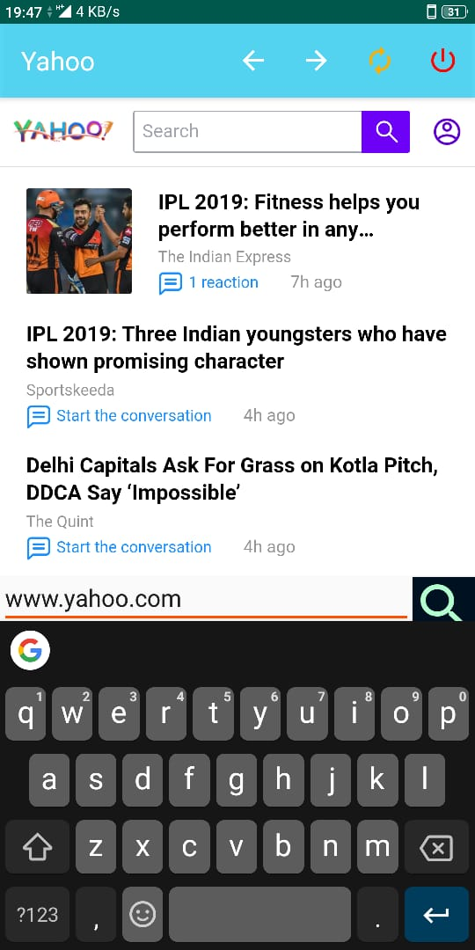

**Address Bar**

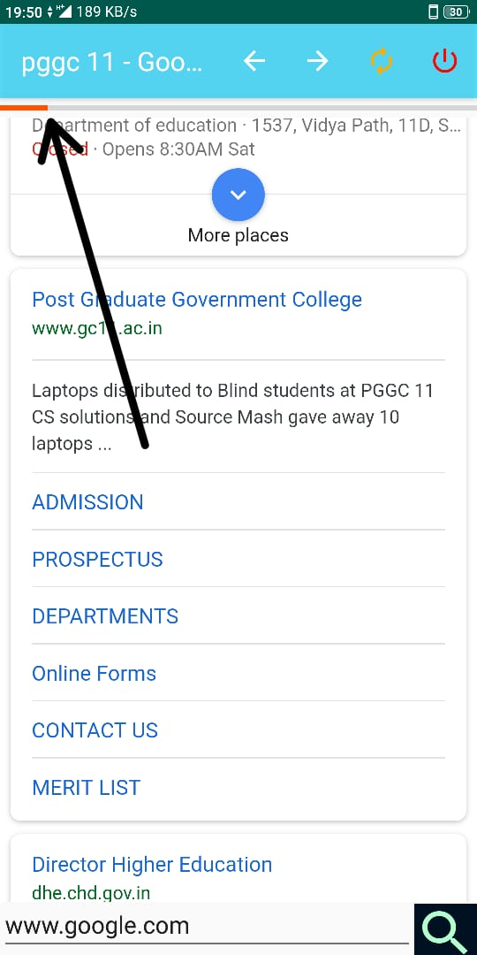

**Page Loader**

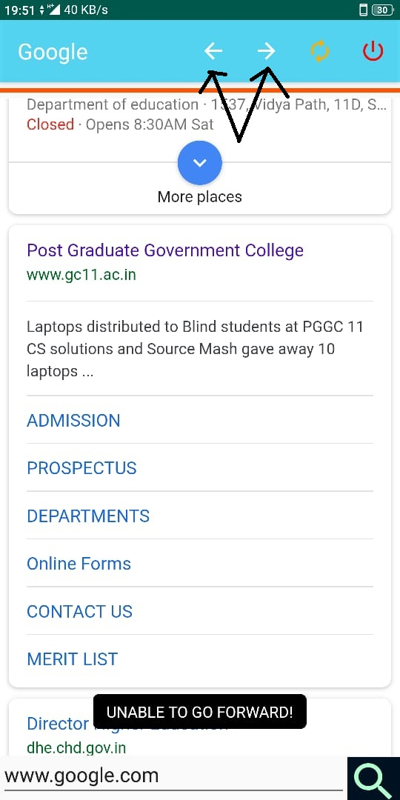

**Forward And Backward Button**

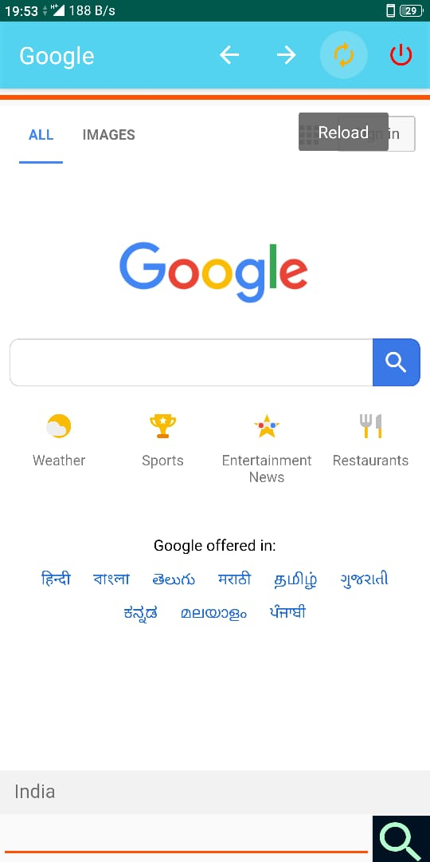

**Quick Reload button**

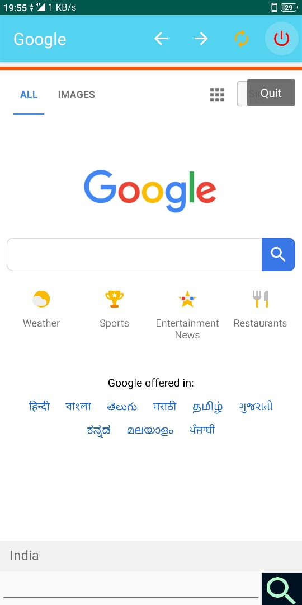

**Dedicated Quit Button**

**SOURCE CODE**

**1.)**ANDROID MANIFEST.xml**-** Every app project must have an AndroidManifest.xml file (with precisely that name) at the root of the [project source set](https://developer.android.com/studio/build/index.html#sourcesets). The manifest file describes essential information about your app permission , Android build tools, the Android operating system, and Google Play.

**CODE:**

<?xml version="1.0" encoding="utf-8"?>

<manifest xmlns:android="http://schemas.android.com/apk/res/android"

package="com.abh.pggc11.webview">

<uses-permission android:name="android.permission.INTERNET"/>

<uses-permission android:name="android.permission.WRITE_EXTERNAL_STORAGE" />

<application

android:allowBackup="true"

android:icon="@mipmap/ic_launcher"

android:label="@string/app_name"

android:roundIcon="@mipmap/ic_launcher_round"

android:supportsRtl="true"

android:theme="@style/AppTheme">

<activity android:name="com.abh.pggc11.webview.MainActivity">

<intent-filter>

<action android:name="android.intent.action.MAIN" />

<category android:name="android.intent.category.LAUNCHER" />

</intent-filter>

</activity>

</application> </manifest>

**2.Activity Main.xml -**It is a layout file for the address bar.

<?xml version="1.0" encoding="utf-8"?>

<LinearLayout xmlns:android="http://schemas.android.com/apk/res/android"

xmlns:app="http://schemas.android.com/apk/res-auto"

xmlns:tools="http://schemas.android.com/tools"

android:layout_width="match_parent"

android:layout_height="match_parent"

android:orientation="vertical"

tools:context="com.abh.pggc11.webview.MainActivity"

android:weightSum="1">

<ProgressBar

android:layout_weight="0.92"

android:id="@+id/myProgressBar"

style="@style/Base.Widget.AppCompat.ProgressBar.Horizontal"

android:layout_width="match_parent"

android:layout_height="match_parent"

/>

<WebView

android:layout_weight="0.08"

android:id="@+id/myWebView"

android:layout_width="match_parent"

android:layout_height="match_parent" >

</WebView>

<LinearLayout

android:weightSum="1"

android:layout_width="match_parent"

android:layout_height="40dp"

android:orientation="horizontal">

<EditText

android:id="@+id/urlText"

android:layout_width="wrap_content"

android:layout_height="wrap_content"

android:layout_weight="0.99"

android:hint="SEARCH HERE.."

android:selectAllOnFocus="false"

android:singleLine="true"

android:textAppearance="@android:style/TextAppearance.DialogWindowTitle"

android:textStyle="italic" />

<Button

android:id="@+id/btn"

android:foreground="@drawable/ic_search_black_24dp"

android:background="#012"

android:layout_weight="0.01"

android:layout_width="45dp"

android:layout_height="45dp" />

</LinearLayout></LinearLayout>

**3.)SuperMenu.xml**- This file is used to create layout for the menu items of the browser for Navigation ,reloading and to exit the application.

**CODE:**

<?xml version="1.0" encoding="utf-8"?>

<menu xmlns:android="http://schemas.android.com/apk/res/android"

xmlns:app="http://schemas.android.com/apk/res-auto" >

<item android:id="@+id/menu_back"

app:showAsAction="always"

android:icon="@drawable/ic_arrow_back_black_24dp"

android:title="Backward" />

<item

android:id="@+id/menu_forward"

app:showAsAction="always"

android:icon="@drawable/ic_arrow_forward_black_24dp"

android:title="Forward" />

<item

android:id="@+id/menu_refresh"

app:showAsAction="always"

android:icon="@drawable/ic_autorenew_black_24dp"

android:title="Reload" />

<item

android:id="@+id/menu_quit"

app:showAsAction="always"

android:icon="@drawable/ic_power_settings_new_black_24dp"

android:title="Quit" /></menu>

**4.MainActivity.java-**The main activity code is a Java file **MainActivity.java**. This is the actual application file which ultimately gets converted to a Dalvik executable and runs your application.

**CODE:**

package com.abh.pggc11.webview;

import android.app.DownloadManager;

import android.net.Uri;

import android.os.Build;

import android.support.annotation.RequiresApi;

import android.support.v7.app.AppCompatActivity;

import android.os.Bundle;

import android.view.Menu;

import android.view.MenuInflater;

import android.view.MenuItem;

import android.view.View;

import android.webkit.DownloadListener;

import android.webkit.WebChromeClient;

import android.webkit.WebView;

import android.webkit.WebViewClient;

import android.widget.Button;

import android.widget.EditText;

import android.widget.ProgressBar;

import android.widget.Toast;

public class MainActivity extends AppCompatActivity {

//CREATING THE OBJECTS

ProgressBar superProgressBar;

WebView superWebView;

Button superGO;

EditText superUrl;

@Override

protected void onCreate(Bundle savedInstanceState) {

super.onCreate(savedInstanceState);

//FINDING BY ID"S

setContentView(R.layout.activity_main);

superGO =findViewById(R.id.btn);

superUrl = findViewById(R.id.urlText);

superProgressBar = findViewById(R.id.myProgressBar);

superWebView = findViewById(R.id.myWebView);

//USING THE OBJECTS

superProgressBar.setMax(100);

superWebView.loadUrl("https://www.google.com");

superWebView.getSettings().setJavaScriptEnabled(true);

superWebView.setWebViewClient(new WebViewClient());

//CREATING A WEB_VIEW CLIENT

superWebView.setWebChromeClient(new WebChromeClient(){

//METHOD FOR PROGRESS BAR

@Override

public void onProgressChanged(WebView view, int newProgress) {

super.onProgressChanged(view, newProgress);

superProgressBar.setProgress(newProgress);

}

@Override

public void onReceivedTitle(WebView view, String title) {

super.onReceivedTitle(view, title);

getSupportActionBar().setTitle(title);

}

});//WEB CHROME CLIENT ENDS

superWebView.setDownloadListener(new DownloadListener() {

@Override

public void onDownloadStart(String url, String userAgent, String contentDisposition, String mimetype, long contentLength){

DownloadManager.Request myRequest = new DownloadManager.Request(Uri.parse(url));

myRequest.allowScanningByMediaScanner();

myRequest.setNotificationVisibility(DownloadManager.Request.VISIBILITY_VISIBLE_NOTIFY_COMPLETED);

DownloadManager myManager = (DownloadManager) getSystemService(DOWNLOAD_SERVICE);

myManager.enqueue(myRequest);

Toast.makeText(MainActivity.this, "DOWNLOAD STARTED!", Toast.LENGTH_SHORT).show();

}

});

//METHOD FOR GO BUTTON

superGO.setOnClickListener(new View.OnClickListener() {

@Override

public void onClick(View view) {

//COLLECTING THE DATA FROM EDIT_TEXT

String urlString = superUrl.getText().toString();

//PASSING THE STRING TO THE LOAD_URL_METHOD

if (urlString.startsWith("yahoo") || urlString.endsWith("yahoo")){

urlString ="https://in.search.yahoo.com/search?p="+urlString;

superWebView.loadUrl(urlString);}

else if (urlString.startsWith("bing") ||urlString.endsWith("bing")) {

urlString ="https://www.bing.com/search?q="+urlString;

superWebView.loadUrl(urlString);

}

else{

urlString = "https://www.google.com/search?q="+urlString;

superWebView.loadUrl(urlString);

} }});

}

//ON_CREATE METHOD ENDS***************************

@Override

public boolean onCreateOptionsMenu(Menu menu) {

MenuInflater menuInflater = getMenuInflater();

menuInflater.inflate(R.menu.super_menu, menu);

return super.onCreateOptionsMenu(menu);

}

//*****************************************************

@RequiresApi(api = Build.VERSION_CODES.O)

//METHOD FOR MENU BUTTONS***************************

@Override

public boolean onOptionsItemSelected(MenuItem item) {

switch (item.getItemId()){

case R.id.menu_back:

onBackPressed();

break;

case R.id.menu_forward: onForwardPressed();

break;

case R.id.menu_refresh: superWebView.reload();

break;

case R.id.menu_quit : onQuitPressed();

break;

}

return super.onOptionsItemSelected(item);

}

//UD METHOD FOR QUIT ACTION*************************************

private void onQuitPressed(){

Toast.makeText(this, "QUITING THE BROWSER !!!", Toast.LENGTH_SHORT).show();

finish();

}

// CREATING A CUSTOM METHOD FORWARD PRESS BUTTON****************************

private void onForwardPressed(){

if(superWebView.canGoForward()){

superWebView.goForward();

}

else{

Toast.makeText(this, "UNABLE TO GO FORWARD!", Toast.LENGTH_SHORT).show();

}

}

//METHOD FOR BACK PRESSING***************************8

@Override

public void onBackPressed() {

if(superWebView.canGoBack()){

superWebView.goBack();

}

else{

Toast.makeText(this, "CAN'T GO BACK AT THIS STAGE!", Toast.LENGTH_SHORT).show();

}

}

}//******MAIN_ACTIVITY ENDS***********

**CONCLUSIONS**

* We can conclude that webview class can be used to

create web page viewing applications and it’s various methods can be used to implement various features like

loading url, going backward and forward through webpages

reloading webpages etc.

**Limitations:**

* It doesn’t support history and multiple tab feature.

**Future scope of project:**

* The application can be further modified to integrate various

Features of a more advance web browser .

**Bibliography**

* [*www.developer.android.com*](http://www.developer.android.com)
* [*www.stackoverflow.com*](http://www.stackoverflow.com)
* [*www.tutorialspoint.com*](http://www.tutorialspoint.com)